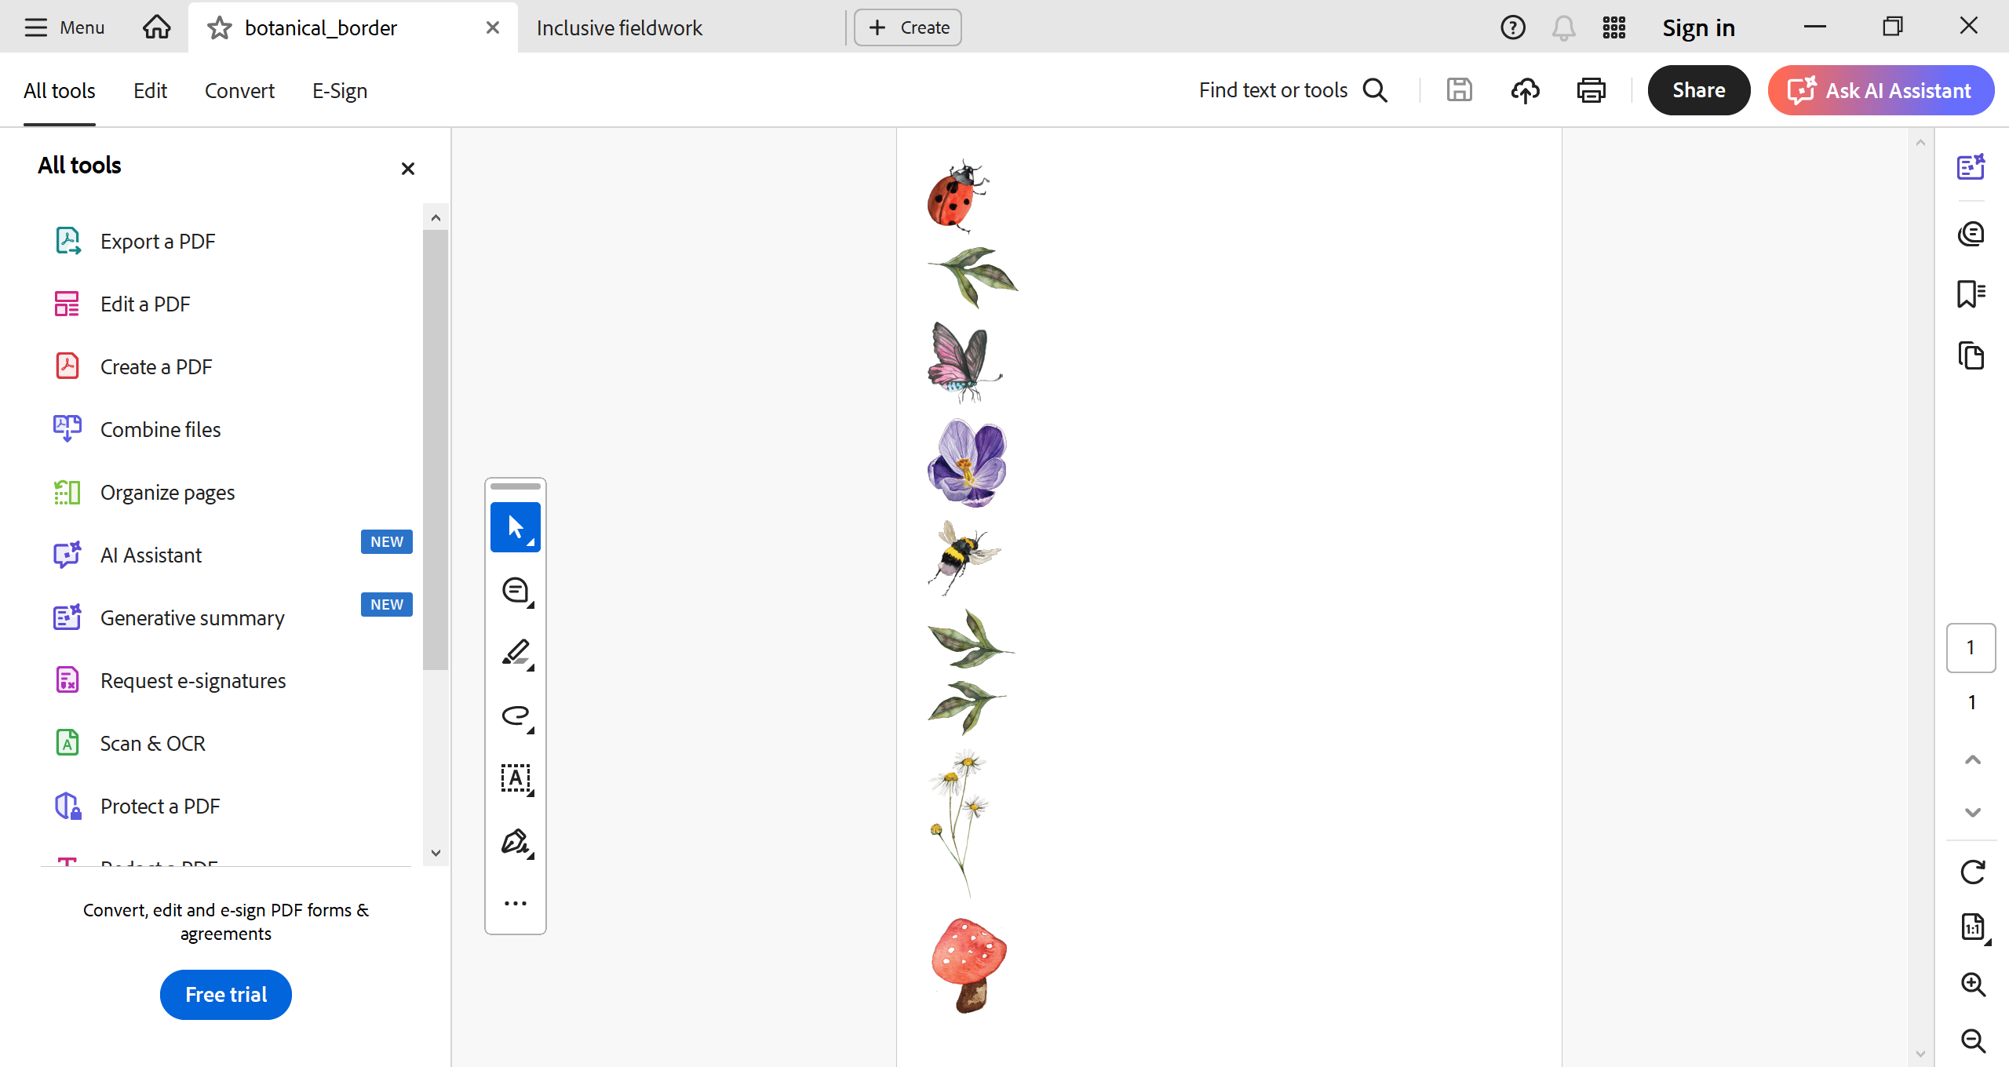
Inclusive fieldwork
Fieldwork is a core part of both research and education in biology and environmental science. For many students, fieldtrips are a major attraction to the biological sciences but for others, fieldwork presents a barrier to studying or enjoying biology at university and may limit their desire or ability to continue in the field of biology, even if they otherwise enjoy or excel in it.
A pressing but often overlooked barrier to inclusivity in fieldwork is the issue of toilet stops and menstruation in the field. Our guidance document on the SBES website includes sections for both staff and students, and has lots of information on the pros and cons of different period products, other things to pack for fieldwork, and additional reading. The main points are summarised below, but check out the full document for more details (also available for staff via the SBES intranet).
Let’s talk.
Are you an SBES staff member who needs to ensure that your fieldtrip is inclusive? Or are you a student embarking on fieldwork for the first time, or going to a new field site, and want to discuss periods and/ or toilet stops? There are lots of postgraduate students and staff members who can answer your questions and share advice.
Get in touch with any of the inclusive fieldwork contact points - we’re happy to talk.
ruth.leeney1@ucd.ie / jeanette.carlsson@ucd.ie (SBES staff)
eliza.fairchild@ucdconnect.ie (PhD student & EDI representative) / niamh.kennedy6@ucdconnect.ie (PhD student)

Students:
Things to consider for managing a period on field work include:
- How long you will be away.
- The local conditions – climate, availability of period products, availability of running water….
- Being responsible in the field – packing out used period products when no disposal is possible.
- Associated symptoms – if you get headaches or other symptoms as part of your cycle, it’s important to plan for these, too.

Don’t dehydrate! Restricting fluid intake can have potential downstream health impacts such as urinary tract infections or dehydration.
Staff:
- Planning a fieldtrip? Mention where and roughly when toilet and washing facilities will occur.
- Build toilet stops into the schedule, and ensure those are conveyed to students ahead of time.
- Identify an individual to whom students and team members can talk - a point of contact and discreetly help people to manage their period.
- For longer-term, more remote trips, consider discussing availability of menstrual products field conditions and local culture with team members and students, or ask a contact point (see below) to do this.
- Carry an emergency period kit alongside your first aid kit.

